Hacker Rank Day 2
Task 1
The provided code stub reads two integers, and , from STDIN.
Add logic to print two lines. The first line should contain the result of integer division, // . The second line should contain the result of float division, / .
No rounding or formatting is necessary.
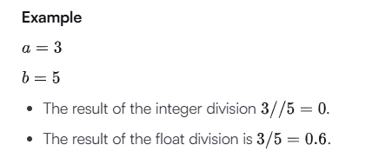
Print:
0
0.6
Input Format
The first line contains the first integer, .
The second line contains the second integer, .
Output Format
Print the two lines as described above.
Sample Input 0
4
3
Sample Output 0
1
1.33333333333

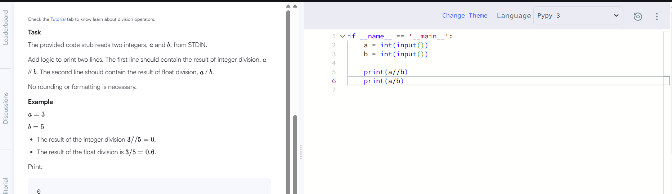
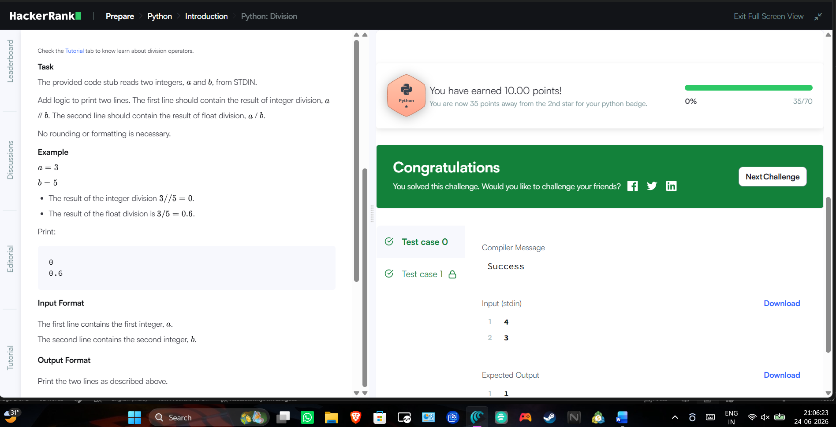

Task 2
The provided code stub reads an integer, , from STDIN. For all non-negative integers , print .
Example
The list of non-negative integers that are less than is . Print the square of each number on a separate line.
0
1
4
Input Format
The first and only line contains the integer, .
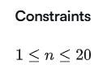
Output Format
Print lines, one corresponding to each .
Sample Input 0
5
Sample Output 0
0
1
4
9
16
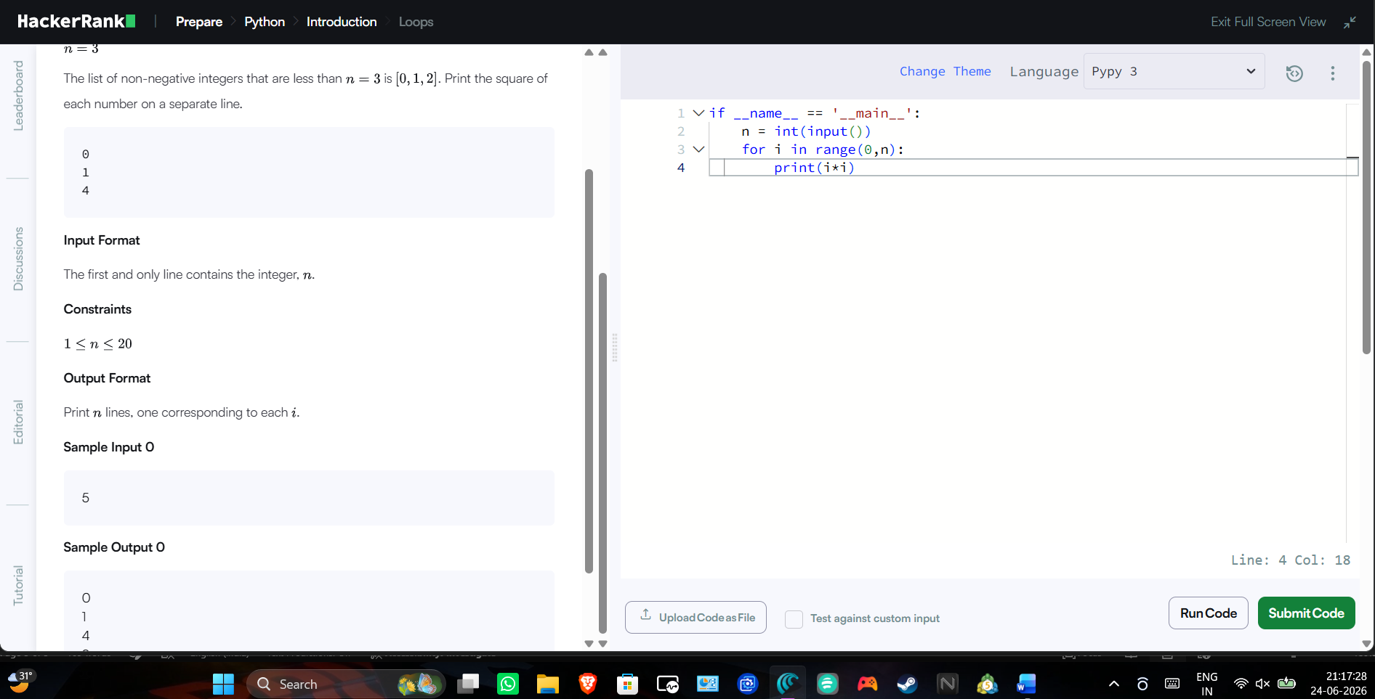
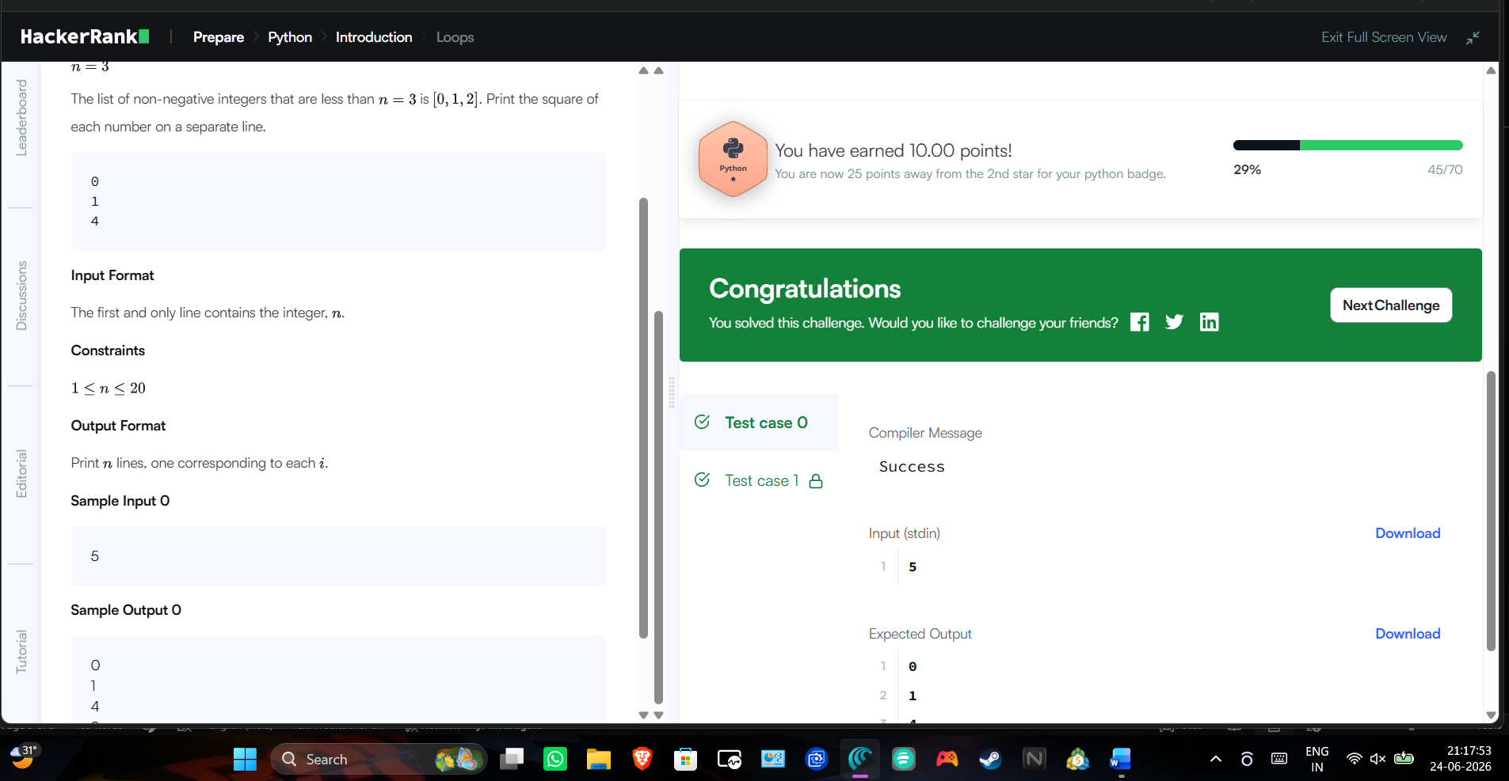
Task 3
An extra day is added to the calendar almost every four years as February 29, and the day is called a leap day. It corrects the calendar for the fact that our planet takes approximately 365.25 days to orbit the sun. A leap year contains a leap day.
In the Gregorian calendar, three conditions are used to identify leap years:
- The year can be evenly divided by 4, is a leap year, unless:
  - The year can be evenly divided by 100, it is NOT a leap year, unless:
    - The year is also evenly divisible by 400. Then it is a leap year.
This means that in the Gregorian calendar, the years 2000 and 2400 are leap years, while 1800, 1900, 2100, 2200, 2300 and 2500 are NOT leap years.
Given a year, determine whether it is a leap year. If it is a leap year, return the Boolean True, otherwise return False.
Note that the code stub provided reads from STDIN and passes arguments to the is_leap function. It is only necessary to complete the is_leap function.
Input Format
Read , the year to test.
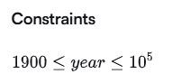

Output Format
The function must return a Boolean value (True/False). Output is handled by the provided code stub.
Sample Input 0
1990
Sample Output 0
False
Explanation 0
1990 is not a multiple of 4 hence it's not a leap year.
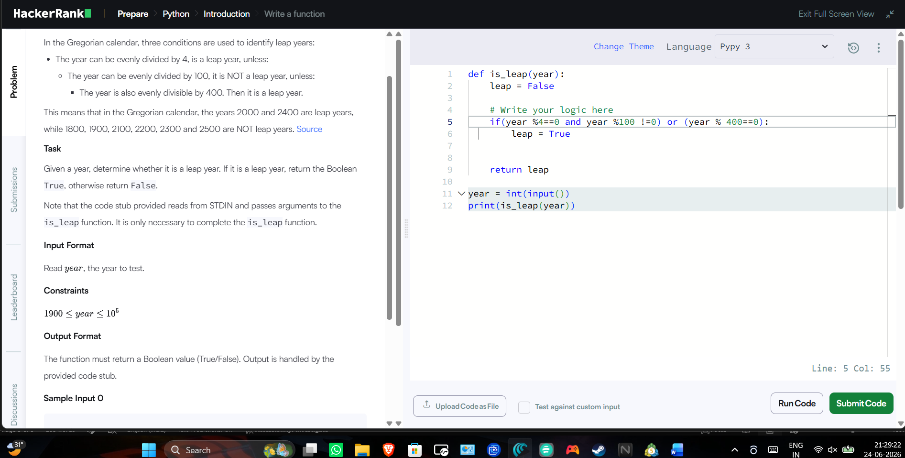
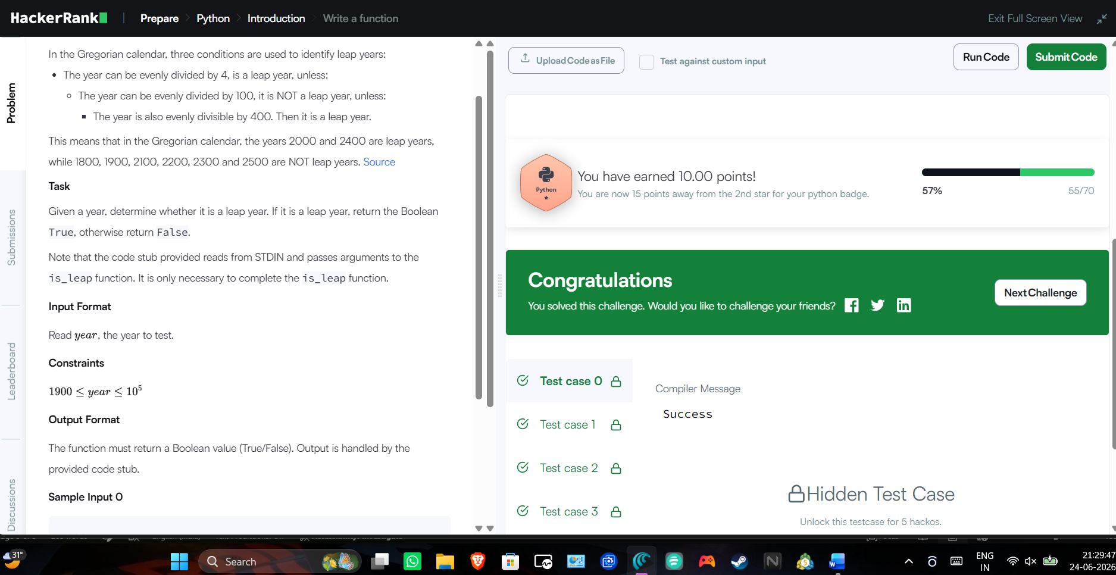

Task 4
The included code stub will read an integer, , from STDIN.
Without using any string methods, try to print the following:
Note that "" represents the consecutive values in between.
Example
Print the string 12345.
Input Format
The first line contains an integer .
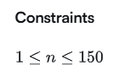
Output Format
Print the list of integers from through as a string, without spaces.
Sample Input 0
3
Sample Output 0
123
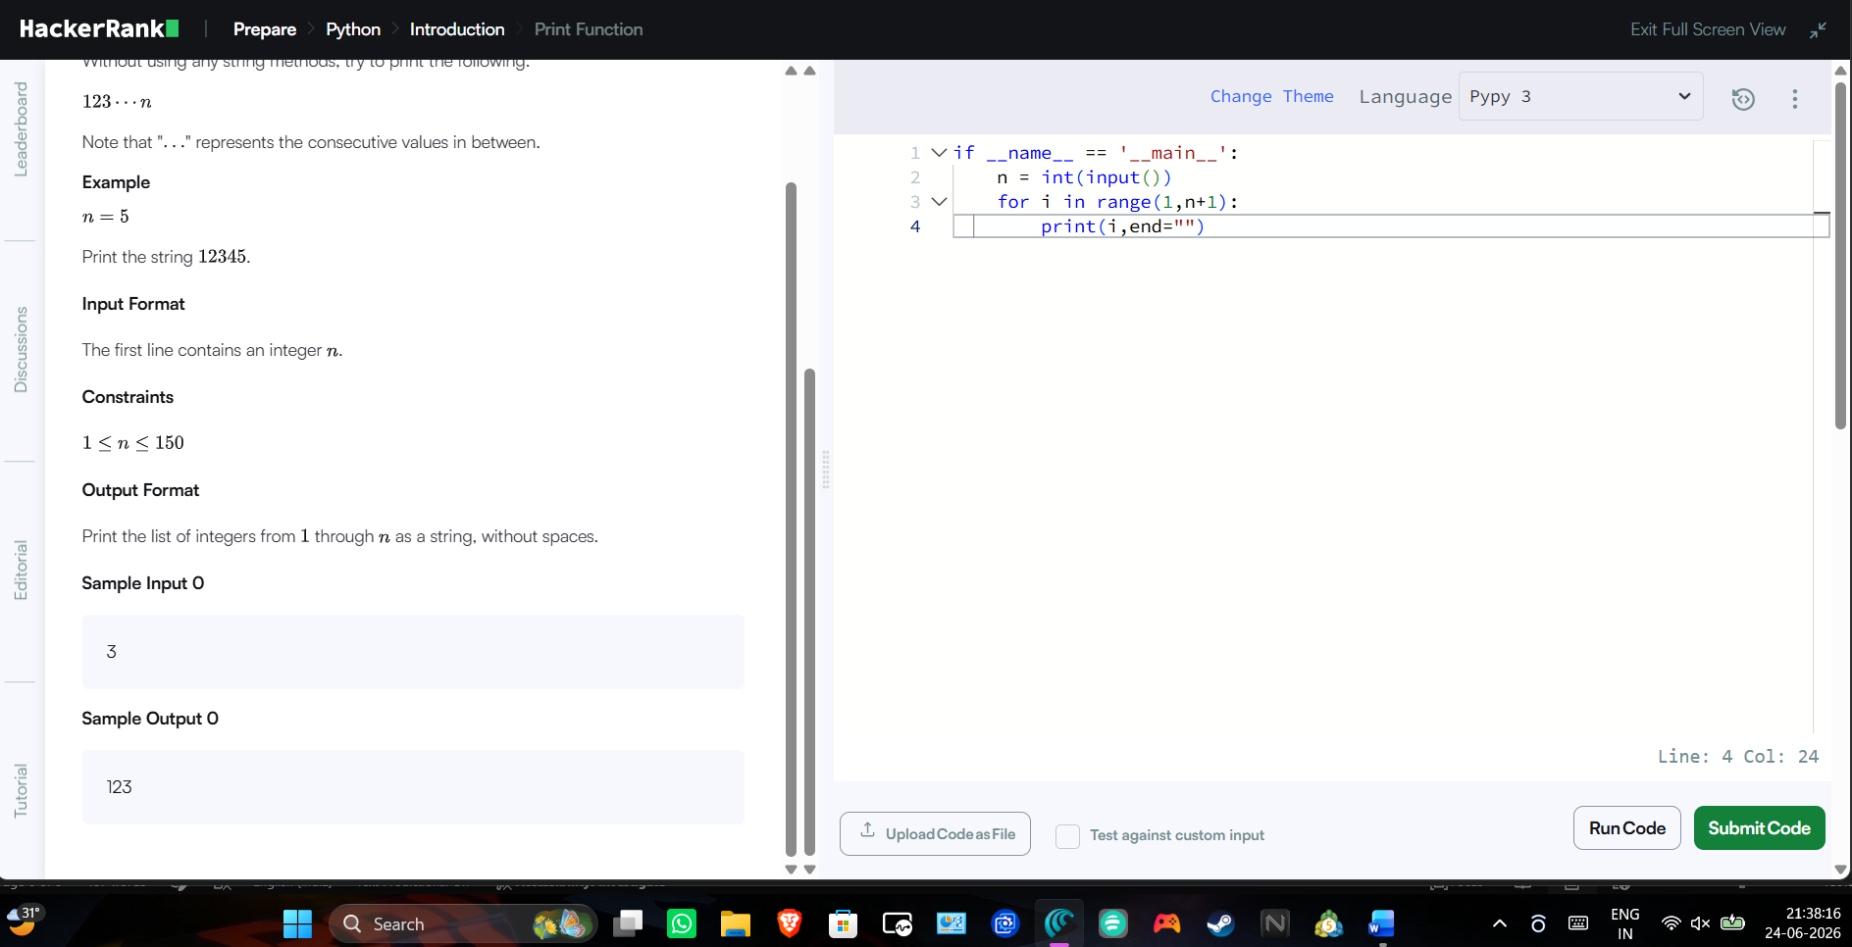

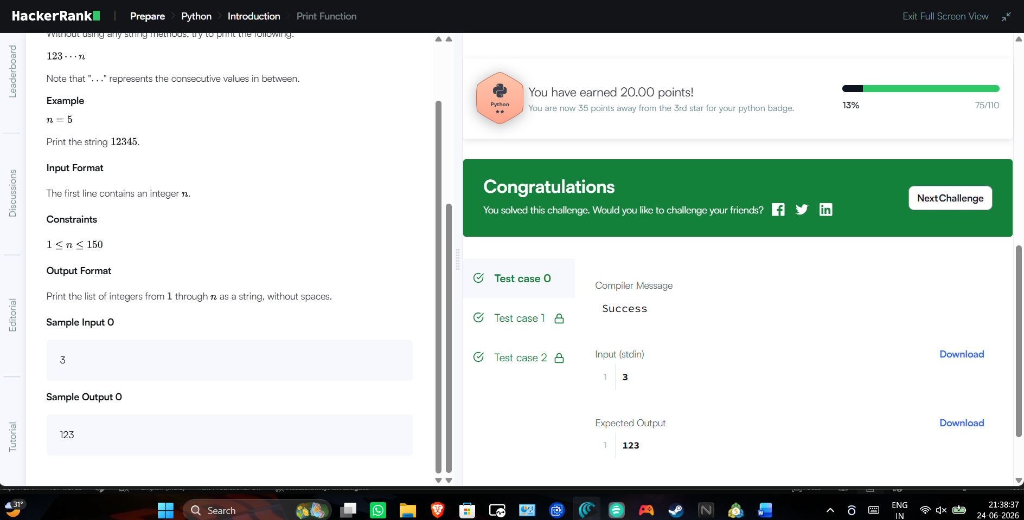

Task 5
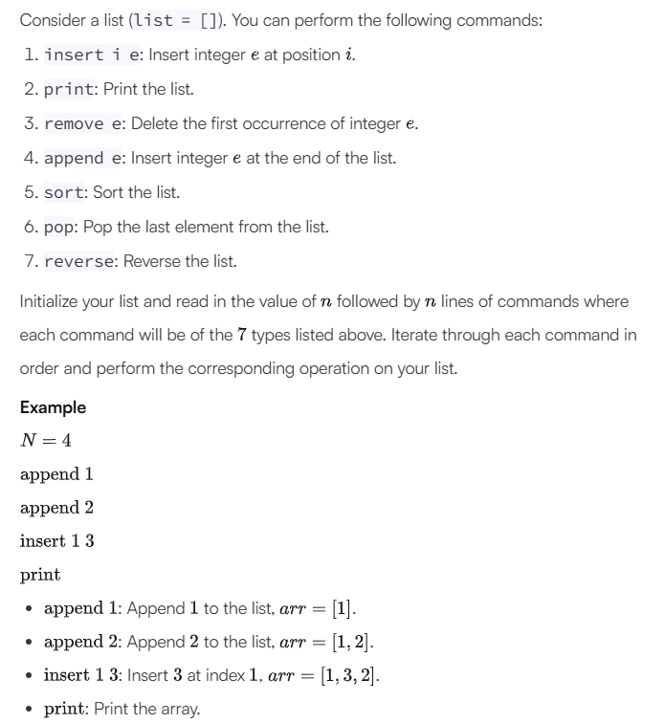
- Output:
[1, 3, 2]
Input Format
The first line contains an integer, , denoting the number of commands.
Each line of the subsequent lines contains one of the commands described above.
Constraints
- The elements added to the list must be integers.
Output Format
For each command of type print, print the list on a new line.
Sample Input 0
12
insert 0 5
insert 1 10
insert 0 6
print
remove 6
append 9
append 1
sort
print
pop
reverse
print
Sample Output 0
[6, 5, 10]
[1, 5, 9, 10]
[9, 5, 1]
